AUTUMN CONCERT

Saturday 25th November at 7.30pm
at
St. James’ Church Nunburnholme
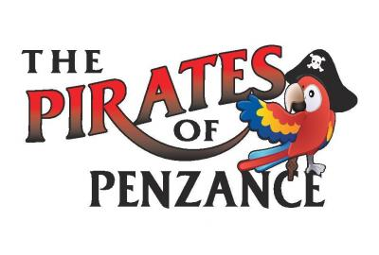
The Celebration Singers Perform the music of Gilbert and Sullivan’s comic operetta
Tickets £5 including welcome drink
Available from Ann Hill– 01759 304311 and
Mike Hastings – 01579 318623
or at the door on the night.

